Luz Deloria

**Wireshark Lab2 – HTTP**

9/16/18

1. Is your browser running HTTP version 1.0 or 1.1?

* **HTTP 1.1**

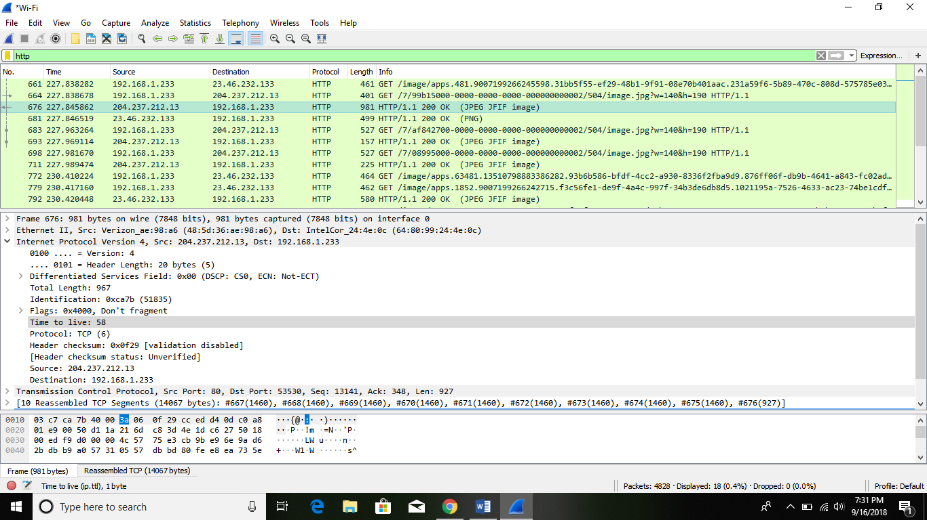

1. When was the HTML file that you are retrieving last modified at the server?

* 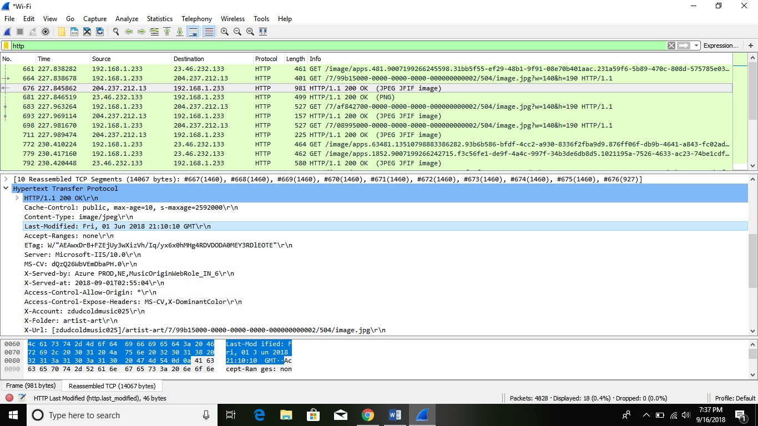



1. What is the IP address of your computer? Of the gaia.cs.umass.edu server?

* 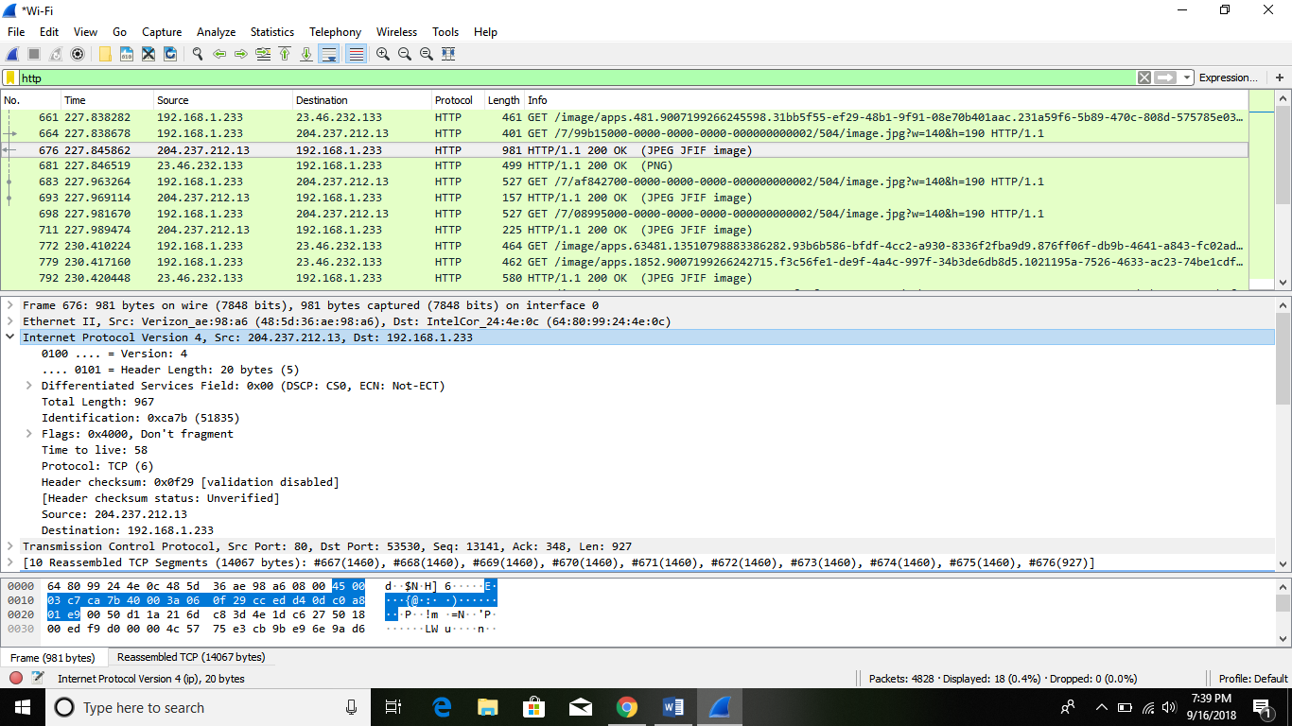



4.What languages (if any) does your browser indicate that it can accept to the server?

* 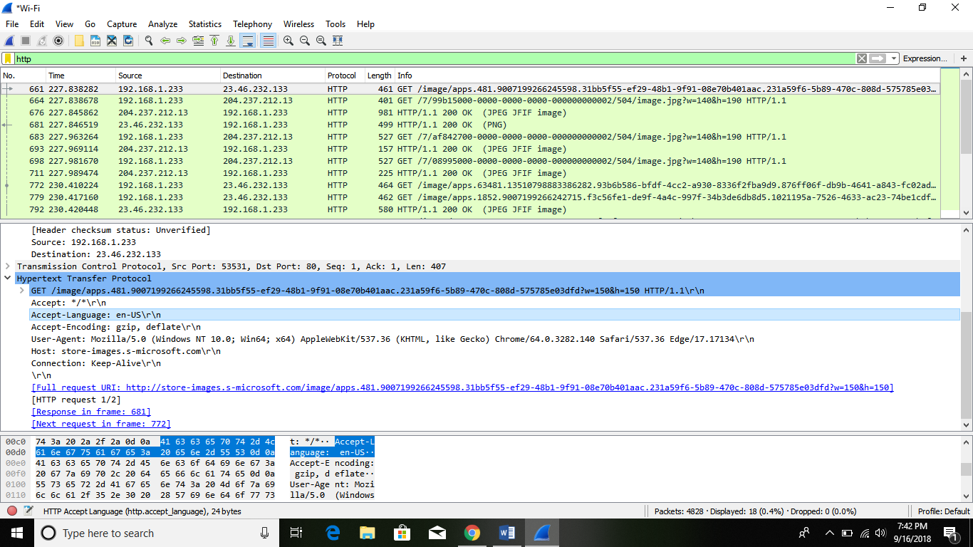



1. When was the HTML file that you are retrieving last modified at the server?

* 

